Personal Profile

Willem MacNamara |03/10/1999 | s3778866 | s3778866@student.rmit.edu.au

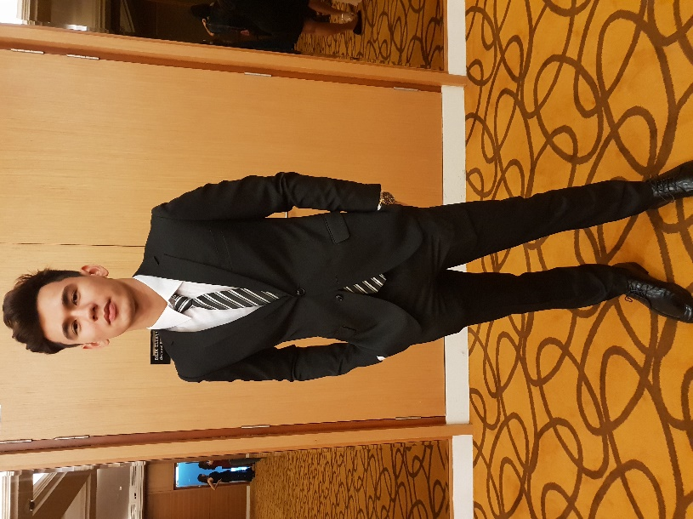   
  
 That’s me by the way!  
   
  
   
  
  
  
 ***Quick summary about myself!***  
   
 I have two nationalities, Malaysian and Australian, born and raised in Malaysia and came to Australia in late 2018. My main spoken language is Cantonese, second would be Mandarin and last would be English. I do multiple sports of interest such as Badminton, Futsal, Mountain biking, long distance running (10km), but not as often as I would l0ve to due to work and studies at the moment.

***Interest in IT (Information Technology)***   
  
I’ve always been fascinated with technology in general since I had my first Personal Computer when I was just 14, and not just how they operate but the people working behind it, how they create something so advance using complex coding and the countless hours required to make it.  
  
I would say that I feel in love with technology after I had my first laptop, I felt like I was in the matrix, with infinite amount of information, games, convenience of doing my essay and school work with all the tools I’ll ever need.  
  
Why did I choose RMIT? To be honest, when I saw the word, Royal Melbourne of Institution of Technology, it just caught my attention and I had friends studying there too, haha. But I did my research and RMIT is best known in Melbourne for the course that I’m interest in, which is Computer Science. I have no experience in IT whatsoever but I’m always ready to learn new things every day.  
  
Hopefully, I’ll be able to understand and apply basic knowledge from what I’ve learn in this course into my daily life and further my studies into a specialist of one or more fields in Computer Science.  
  
  
  
 ***Ideal job – Web Developer/Programmer (***[***https://www.youtube.com/watch?v=nKIu9yen5nc***](https://www.youtube.com/watch?v=nKIu9yen5nc)***)***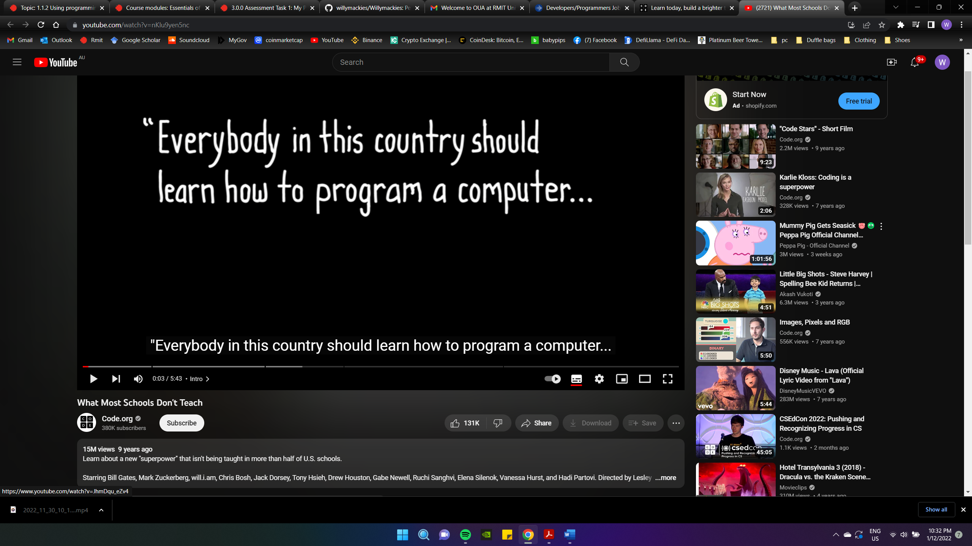

A Web Developer or Programmer is someone who build websites, create apps, or/and writing a software program for multiple tasks, it’s what we use in our daily life and I find that really intrigue because we usually don’t ask the question ‘How was it created?’, ‘How is it possible for something so small to store that much data and information with just a click/press of a button?’. I’m more interesting in experiencing it then just hearing from it online.

Setting up a program requires at least the knowledge of one software language and the rest would follow the same principle but with different words. You would need to understand the fundamentals of the languages of how it operates and a lot of time and effort before you can actually build a fully functioning website, but they are some open-source codes online you can copy or learn how it works.

Currently I’ve just started learning Programming and learning my first language, which is phyton, with zero knowledge and experience whatsoever, and I love it! Sometimes learning something new that interest you is really all you need in life.

Doing an Online course at RMIT about IT is just a stepping stone for me to build up that foundation needed for in-depth Knowledge about being a Programmer with a qualification for that specific role that I’m currently interested in and I’m glad that I finally took my first step into reaching that goal!